Flowers for Algernon – Part I: Study Guide

1. Answer the following questions about the story.
2. What is Charlie’s IQ at the beginning of the story?
3. Why does Charlie go to Miss Kinnian’s class?
4. What does Charlie see the first time he looks at the inkblots?
5. Why is Charlie chosen for the assignment?
6. Before the operation, what does Charlie think of Joe Carp and Frank Reilly? How do they treat him?
7. What does it mean to “do a Charlie Gordon”?
8. How can the reader tell that Charlie is getting smarter after the operation?
9. Explain Charlie’s feelings toward Algernon before and after the operation.
10. What happens on Charlie’s second outing with Frank and Joe?
11. At the beginning of the story, Charlie takes a Rorschach Test. In this test, someone is shown an inkblot and asked to tell what they see in the ink. There is no right answer. Try it out. Look at the inkblots below and tell me what you see.
12.  2. 3.
13. Charlie and Algernon race through mazes. Algernon must find his way to the cheese in order to eat, but Charley finds his way on paper with a pencil. Can you find your way through the maze below?

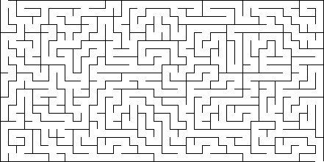

1. Define the following words and explain how each word relates to the story. Write a complete sentence when you explain.

|  |  |  |
| --- | --- | --- |
| Word | Definition | Relationship to Story |
| Example: Animal Testing | The use of animals as subjects in scientific research. | Algernon, a mouse, is being used for research in this story. |
| 1. Intelligence |  |  |
| 1. IQ |  |  |
| 1. Raw Shock   (Rorschach) |  |  |
| 1. Phonetically |  |  |
| 1. Progress Report |  |  |

1. Why does Charlie want to be smart?
2. What is Algernon’s motivation? What is Charlie’s?
3. What is the major risk of the operation?
4. What kind of person is Miss Kinnian? How do you know? GIVE SPECIFIC EXAMPLES!
5. What sickness keeps Charlie home from work for the firs time ever?
6. This story is written in Progress Reports which tells us that the events are chronological.

Define the word *chronological* using a dictionary.

1. When is the first time that Charley realizes that he is is smarter?
2. Why is Algernon such a smart mouse?
3. DISCUSSION QUESTION: When Charlie figures out that people have been making fun of him he feels ashamed. Do you think he was better off before the operation? Explain.

Test Friday!!! I will give back the study guides and go over them with you on Thursday!