8th Grade Poetry “Scavenger Hunt” Test
Directions: Use your book and notes to answer the following questions.
1. Page 536- Identify the alliteration in line 8 of Robert Frost’s “The Road Not Taken”
__________________________________________________________________________________________________
2. True/False – The difference between a poem and a story is that poems rhyme.
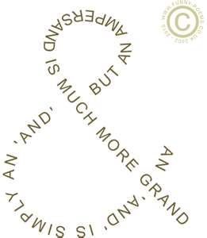
3. This poem is an example of
a. Epic Poetry
b. Haiku
c. Lyric Poetry
d. Concrete Poetry

4. The words prisoner and inmate have
a. the same denotation but different connotations.
b. the same connotation but different denotations.
c. the same connotation and denotation
d. different denotations and connotations
5. Would you prefer to read an epic poem or a limerick? Why? Be sure to demonstrate your understanding of the definitions of these two poetic styles.
____________________________________________________________________________________________________________________________________________________________________________________________________
6. The train was an angry animal roaring down the tracks is an example of
a. simile
b. metaphor
c. onomatopoeia
d. hyperbole
7. The baby’s skin was like a rose petal is an example of
a. simile
b. metaphor
c. onomatopoeia
d. hyperbole
8. On page 472, write the fifth line of this poem in the space below
__________________________________________________________________________________________________
9. On page 504, read lines 9 and 10. BE CAREFUL: the line does not end with bugle. Line 9 and 10 end with the words ______________ and ________________. What type of rhyme is this?________________________________________
10. What is the first word of the third stanza on page 447? __________________________________________________
11. What is the rhyme scheme of the third stanza on page 447? ______________________________________________
12. Look at the poems on page 447 and 453. Which poem contains a quatrain? __________________________________________________________________________________________________
13. Write the refrain from the following poem on the space provided.
__________________________________________________________________________________________________

“Dreams” by Langston Hughes

Hold fast to dreams
For if dreams die
Life is a broken-winged bird
That cannot fly.
Hold fast to dreams
For when dreams go
Life is a barren field
Frozen with snow.

