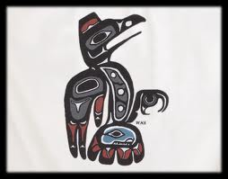
Lesson Plan: Identify Sequence to Enhance Understanding
Miss Campbell Grade ________ Date ________

Teacher will go over homework from the night before and allow a few students to share their origin myths.

Teacher will review with students the notes from the day before by asking them what they expect to find in the story “How the World Was Made.”

The teacher will have the students add the vocabulary words to their index collection.

Teacher will have one student come to the board and while other students read aloud the story. The student at the board will draw the earth as the myth describes it to provide a visual representation of the tale.

Teacher will ask students to create a timeline for the creation of the world as it is described in the myth.
Underworld?
Sky/water animals/plants mud earth sun humans

Discussion

- What do we learn about the Cherokee people from reading this myth?
- What images come to mind when you think about the water beetle? What does it say about the Cherokee people that the water beetle created the earth?
- Do you think it is significant that the animals were created first and then they created the earth, man, etc.? What practical reason might justify the animals being created first?

Writing Activity:
ADVANCED- Think about American culture today, our ideals and our customs. How would this myth differ if it was written in this era?
- Ideas may include: hard work rewarded, greed, ownership, rights, democracy, freedom, power of knowledge, etc.
STANDARD- “Writing about literature” on page 26.

Homework: Find another creation story. How is it similar and different then the story we read today?

