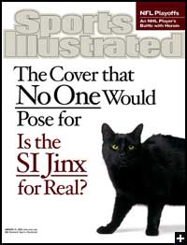
The Sports Illustrated Cover Jinx
by Sports Illustrated Writer, Alexander Wolff
Many superstitious readers, and many famous athletes, believe that an appearance on the cover of Sports Illustrated Magazine is the kiss of death. That’s why I decided to explore this superstition—Is the Jinx Real? I asked Kurt
Warner to appear on the cover along side the black cat to illustrate the point, but Warner, a believer in the curse, refused; so the cat does a solo turn on the cover that No One would pose for.
In researching the curse I talked to statisticians who explained “the regression to the mean.” This theory explains the curse through the fact that anyone who makes the cover of SI is an extreme, and the probability is high that any extreme will eventually regress to the norm. SO, a hitter who gets enough hits to make the cover is likely to eventually reach a slump—thus the curse.
Another explanation was provided by a sport’s psychologist, Jim Loehr. His theory about the curse is that when expectations are heightened for athletes by things like appearing on the cover, they essentially psych themselves out.
Over the year, 2,456 covers have been shot for SI. Of these, 913 were “jinxes.” That’s 37.2 percent! Golfers were jinxed almost 70 percent of the time!

